|  |  |  |
| --- | --- | --- |
| Related image | **KONERU LAKSHMAIAH EDUCATION FOUNDATION**  (Deemed to be University estd, u/s, 3 of the UGC Act, 1956) (NAAC Accredited “A++” Grade University)  Green Fields, Guntur District, A.P., India – 522502  **Department of Computer Science and Engineering**  (DST - FIST Sponsored Department) |  |

**B.Tech. II CSE(H) PROGRAM**

**A.Y. 2023-24 ODD, Semester-II**

**Course Code: 22MT2005**

**PROBABILIRT, STATISTICS AND QUEUING THEORY**

**Course Outcome-1**

**Session 3: ADDITION RULE & MULTIPLICATION RULE**

1. **Course Description (Description about the subject)**

In this session the basic rules of probability are discussed, which deals with the addition and multiplication rules.

1. **Aim**

To define the concepts of addition and multiplication rules of probability.

1. **Instructional** **Objectives (Course Objectives)**

1.If two events are mutually excusive we use the addition rule

2. The multiplication rule enables one to compute the probability of one event and another occurring. Recall that the addition rule enables one to calculate the probability of one event or another occurring.

1. **Learning** **Outcomes (Course Outcome)**

**CO1**: Students will be able to apply the basic rules of Probability.

1. **Module** **Description** **(CO-2 Description)**

Probability, addition rules, multiplication rules.

1. **Session** **Introduction**

When calculating the probability of either one of two events from occurring, it is as simple as adding the probability of each event and then subtracting the probability of both of the events occurring: P(A or B) = P(A) + P(B) - P(A and B)

1. **Session description**

**Addition Rule**

Given multiple events, the addition rule for probabilities is used to compute the probability that at least one of the events happens. Probability can be defined as the branch of mathematics that quantifies the certainty or uncertainty of an event or a set of events.

If  and are two events the

**Note:**

1) If A and B are mutually exclusive then

2) For three events A, B and c then

3) If A, B and C are mutually exclusive then

4) If  are n mutually exclusive events then



***source: https://ncert.nic.in/textbook.php?kemh1=16-16***

For three events A, B and C

P(A𝖴 B 𝖴 C) = P(A) + P(B) + P(C) − P(A ∩ B) − P(B ∩ C) − P(C ∩ A) + P(A ∩ B ∩ C)

If A, B and C three mutually exclusive events then

P(A𝖴 B 𝖴 C) = P(A) + P(B) + P(C)

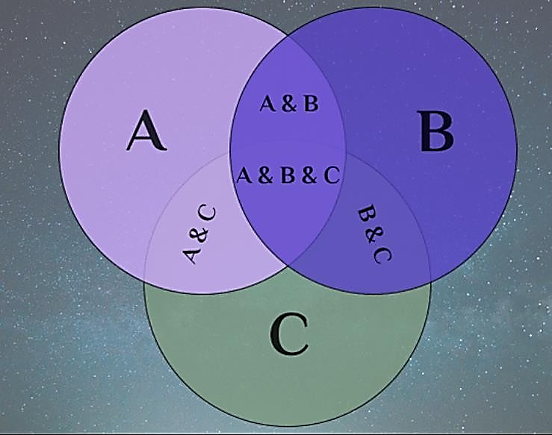

**Some Properties based on Addition Rule**

If A and B are any two events, then

1. P(A and B)=P(both A and B)=P(A∩B)

2. P(at least one)=P(either A or B)= P(A∪B)=P(A)+P(B)-P(A∩B)=P(A or B)

3. P(only A)= P(A)-P(A∩B)=P(A∩B)

4. P(only B)=P(B)-P(A∩B)=P(A∩B)

5. P(any one)=P(only one)=[P(A’∩B)∪P(A∩B’)]= P(A’∩B)+P(A∩B’)

=[P(A)-P(A∩B)] + [P(B)-P(A∩B)]

1. **Activities/ Case studies/related to the session.**
2. The probability of event A happening is 30% and the probability of event B happening is 50%, and the probability of both events happening at the same time is 10%, the probability of either event A or event B happening is 30% + 50% - 10% = 70%. Show it in Venn diagram.
3. **Examples & contemporary extracts of articles/ practices to convey the idea of the Session**

**Example-1:** If A and B are mutually exclusive events P(A) =  3/8 and P(B)  =  1/8, then find P(A U B).

**Solution**: P(A U B)  =  P(A) + P(B) - P(A ∩ B)

Since A and B are mutually exclusive events, P(A ∩ B)  =  0.

P(A U B)  =  (3/8) + (1/8) =  (3 + 1)/8 =  4/8 =  ½

**Example-2:** If A and B are two events associated with a random experiment for which P(A) = 0.35, P(A or B) = 0.85, and P(A and B) = 0.15. Find (i) P(only B) (ii) P(B') (iii) P(only A)

**Solution**: Given that :

P(A) = 0.35, P(A or B) = 0.85, and P(A and B) = 0.15.

(i) P(only B)

First let us find the value of P(B), for that let use the formula for addition theorem on probability.

P(AUB)  =  P(A) + P(B) - P(A ∩ B)

* 0.85  =  0.35 + P(B) - 0.15
* 0.85  =  0.20 + P(B)
* P(B) = 0.85 - 0.20  = 0.65

P(only B)  =  P(A' ∩ B) =  P(B) - P(A∩B) =  0.65 - 0.15 =  0.50

(ii) P(B')

P(B')  =  1 - P(B) =  1 - 0.65 =  0.35

(iii) P(only A)

P(only A)  =   P(A∩B')  =  P(A) - P(A∩B) =  0.35 - 0.15 =  0.20

**Example 3:** Suppose that in a senior college class of 500 students it is found that 210 smoke, 258 drink alcoholic beverages, 216 eat between meals, 122 smoke and drink alcoholic beverages, 83 eat between meals and drink alcoholic beverages, 97 smoke and eat between meals, and 52 engage in all three of these bad health practices. If a member of this senior class is selected at random, find the probability that the student

1. Smokes but does not drink alcoholic beverages.
2. eats between meals and drinks alcoholic beverages but does not smoke;
3. Neither smokes nor eats between meals.
4. Probability that the student does not have any habit

**Solution:** Let A, B, and C be the events that the student selected at random, where A is **smoke**, B is **drink** **alcoholic beverages** and C is **eat between meals**, respectively.

From the given data, P(A)=210/500, P(B)=258/500, P(C)=216/500,

Now, P (A ∩ B)=122/500, P(B ∩ C) =83/500, P(A ∩ C) =97/500 and P (A ∩ B ∩ C)=52/500

1. Probability that the student selected at random smoke A **but** does not drink alcoholic beverages B’

= P(A ∩ B’)= P(A) - P(A ∩ B) = 210/500-(122/500) =88/500

1. Probability that the student selected at random eat between meals C **and** drink alcoholic beverages B **but does not** smoke A’

= P(C ∩ B ∩ A’) = P(B∩ C) - P(A∩B∩C) = (83/500) - (52/500) = 31/500.

1. Probability that the student neither smokes A’ **nor** eats between meals C’

=P(A’∩ C’)=P(A U C)’=1-P(A U C)

=1-[P(A)+P(C) - P(A∩ C)]=1- [(210/500) + (216/500) - (97/500)] =171/500.

1. Probability that the student does not have any habit (i.e. neither smoke A’ nor drink alcoholic beverages B’ nor eat between meals C’)

= P(A’ ∩ B’ ∩ C’) = P(A ∪ B ∪ C)’=1- P(A ∪ B ∪C)

= 1 - [P(A)+P(B)+P(C)-P(A∩B) - P(B∩C) - P(C∩A) +P(A∩B∩C)]

=1 - (434/500) = 66/500.

1. **SAQ's-Self Assessment Questions**
2. In the context of the Addition Rule, when are events considered to be mutually exclusive?

A) When the events have no influence on each other.

B) When the events are not related to the given scenario.

C) When the occurrence of one event excludes the occurrence of the other event.

D) When the events have the same probability of occurrence.

1. What is the formula for the Addition Rule in probability theory for two mutually exclusive events A and B?

A) P(A or B) = P(A) + P(B) B) P(A or B) = P(A) - P(B)

C) P(A and B) = P(A) + P(B) D) P(A and B) = P(A) - P(B)

1. The Multiplication Rule is used to calculate the probability of what type of events?

A) Independent events B) Mutually exclusive events

C) Dependent events D) Complementary events

1. If the probability of event A is 0.6 and the probability of event B is 0.4, what is the probability of both events occurring together if they are independent?

A) 0.8 B) 0.24 C) 0.1 D) 0.2

1. What is the formula for the Multiplication Rule in probability theory for two independent events A and B?

A) P(A and B) = P(A) * P(B) B) P(A and B) = P(A) / P(B)

C) P(A or B) = P(A) * P(B) D) P(A or B) = P(A) / P(B)

1. When are events considered to be dependent in probability theory?

A) When the occurrence of one event does not affect the occurrence of the other event.

B) When the events have the same probability of occurrence.

C) When the occurrence of one event influences the probability of the other event.

D) When the events are mutually exclusive.

**Answer**: 1. C. 2. A, 3. A, 4. B. 5. A, 6. C.

1. **Summary**

Students can be able to solve the problems based on probability of events using addition and multiplication rules.

1. **Terminal Questions**
2. The probability that a consumer testing service will rate a new antipollution device for cars very poor, poor, fair, good, very good, or excellent are 0.07, 0.12, 0.17, 0.32, 0.21, and 0.11. What are the probabilities that it will rate the device

**(a)** very poor, poor, fair, or good;

**(b)** good, very good, or excellent?

1. The probability that a new airport will get an award for its design is 0.16, the probability that it will get an award for the efficient use of materials is 0.24, and the probability that it will get both awards is 0.11.
2. what is the probability that it will get at least one of the two awards?
3. what is the probability that it will get only one of two awards?
4. what is the probability that it will get neither award
5. what is the probability that it will get award for its design only?
6. Consider randomly selecting a student at a certain university, and Let A denote the event the selected individual has a Visa Credit card and B be the analogous event for a Master Card. Suppose that P(A)=0.5, P(B)=0.4 and P(A∩B)=0.25
7. Compute the probability that the selected individual has at least one of the two types of cards
8. Compute the probability that the selected individual has neither type of card
9. Suppose I draw 4 cards from a standard 52-card deck. What is the probability they are all aces (there are exactly 4 aces in a deck)?
10. If an experiment has the three possible and mutually exclusive outcomes *A, B,* and *C*, check in each case whether the assignment of probabilities is permissible:

(a) *P*(*A*) = 1/3*, P*(*B*) =1/3*,* and *P*(*C*) =1/3

(b) *P*(*A*) = 0*.*64*, P*(*B*) = 0*.*38, and *P*(*C*) = -0*.*02

(c) *P*(*A*) = 0*.*35*, P*(*B*) = 0*.*52*,* and *P*(*C*) = 0*.*26

(d) *P*(*A*) = 0*.*57*, P*(*B*) = 0*.*24, and *P*(*C*) = 0*.*19

1. **Case Studies (CO Wise)**

**NA**

1. **Answer Key**

**NA**

1. **Glossary**

**NA**

1. **References of books, sites, links Text Books:**

**Reference books:**

1. Chapter 1 of TP1: William Feller, An Introduction to Probability Theory and Its Applications: Volume 1, Third Edition, 1968 by John Wiley & Sons,Inc.

2. Richard A Johnson, Miller& Freund’s Probability and statistics for Engineers, PHI, New Delhi, 11th Edition (2011).

**Web Resources**

1. https://ncert.nic.in/textbook.php?kemh1=0- 16

2. Notes: sections 1 to 1.3 of http://www.statslab.cam.ac.uk/~rrw1/prob/prob-weber.pdf

3. https://ocw.mit.edu/courses/res - 6 -012 -introduction -to -probability - spring - 2018/91864c7642a58e216e8baa8fcb4a5cb5_MITRES_6_012S18_L01.pd f 9

1. **Keywords**

Probability, addition rules, multiplication rules.